LAB ASSIGNMENT 1.1

DrawHouse

**Assignment:**

Inside your GraphicsIntro project, create a new class called, DrawHouse. Copy the code from DrawShapes into this new class, changing the name DrawHouse. Make this class creates a drawing area of appropriate size (try 500 x 500) and draws a house similar to the one shown below and with these specifications:

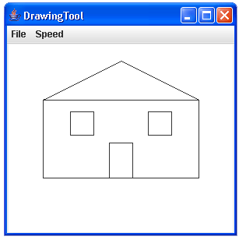

1. The house should fill up most of the drawing area, i.e. draw it big.

2. The house should be centered horizontally on the screen.

3. The house must have a sloped roof. It can be of any slope or configuration. But you cannot have a flat roof on the house.

4. Add a door (centered)

5. Add a windows.

**Instructions:**

1. Include your name as a documentation statement and also a brief description of the program.

2. You will need to turn in (either on paper or electronically) a copy of your code and a picture of the house that resulted into the activity in Schoology called DrawHouse.